THE ROOMMATE
A SHORT FILM PROJECT REPORT ON
PSYCHOLOGICAL HORROR / THRILLER SHORT FILM
PRODUCTION AND DIRECTION
CD23731 – FILM MAKING AND RADIO PODCASTING
Submitted by
YELESWARAM BHARGAV 231701063
in partial fulfillment of the requirements for the award of the degree of
BACHELOR OF ENGINEERING
in
COMPUTER SCIENCE AND DESIGN

 | 

RAJALAKSHMI ENGINEERING COLLEGE, CHENNAI
(Affiliated to Anna University, Chennai)
SEPTEMBER 2026

RAJALAKSHMI ENGINEERING COLLEGE, CHENNAI
(Affiliated to Anna University, Chennai)
BONAFIDE CERTIFICATE
Certified that this Report titled “THE ROOMMATE: A SHORT FILM PROJECT REPORT ON PSYCHOLOGICAL HORROR / THRILLER SHORT FILM PRODUCTION AND DIRECTION” is a bonafide work of YELESWARAM BHARGAV (231701063) who carried out the work under my guidance. Certified further that, to the best of my knowledge, this work does not form part of any other thesis or dissertation submitted for any degree or award.

Signature of the HOD  Dr. S. Vinodh Kumar  Professor and Head  Department of Computer Science and Design  Rajalakshmi Engineering College, Chennai | Signature of the Faculty-in-charge  Dr. Gunasekar S  Assistant Professor  Department of Computer Science and Design  Rajalakshmi Engineering College, Chennai
Submitted for the project viva-voce examination held on ______________

Signature of Internal Examiner | Signature of External Examiner

ABSTRACT

“The Roommate” is a psychological horror short film of approximately 3 minutes and 42 seconds, conceived, scripted, shot, and edited as part of the CD23731 – Film Making and Radio Podcasting course. The film follows a young man who is jolted awake in his bedroom at night by an unexplained red light and an unsettling phone call, and who spends the remainder of the film trying to determine whether he is alone in the room. Rather than relying on jump scares or explicit imagery, the film builds tension through controlled lighting changes, shadow play, silhouette staging, and a slow narrowing of the frame toward a single candlelit mirror shot.
This report documents the complete filmmaking process undertaken for the project, covering pre-production (concept development, script and shot breakdown, location scouting, and equipment planning), production (lighting setup, camera blocking, and on-set direction of a single performer), and post-production (editing, colour treatment, and sound design). The report also documents the equipment and software used, the technical and logistical challenges encountered while filming with minimal crew and equipment, and the key learnings drawn from planning and executing a mood-driven, dialogue-light narrative within a short runtime. The final output is a single-location short film that relies on lighting design and shadow as its primary storytelling tools, supported by the film's own production stills and screenshots included in this report.

ACKNOWLEDGEMENT

I would like to express my sincere gratitude to everyone who supported me through the making of this short film. I thank the Almighty for guidance and strength throughout this endeavour.
I extend my heartfelt thanks to our Chairman Mr. S. Meganathan, B.E., F.I.E., our Vice Chairman Mr. Abhay Shankar Meganathan, B.E., M.S., and our respected Chairperson Dr. (Mrs.) Thangam Meganathan, Ph.D., for providing the requisite infrastructure and facilities. I sincerely thank Dr. S. N. Murugesan, M.E., Ph.D., our beloved Principal, for his kind support.
I am extremely grateful to my Faculty-in-charge, Dr. Gunasekar S, Assistant Professor, Department of Computer Science and Design, for his valuable guidance, patient feedback, and support at every stage of this project – from scripting to the final edit.
Finally, I thank my friends and family who supported the shoot, whether by helping set up lighting equipment, holding reflectors, or simply staying quiet during takes.

YELESWARAM BHARGAV – 231701063

TABLE OF CONTENTS

Ch. No. | Title | Page No.
 | Abstract | iii
 | Acknowledgement | iv
 | List of Figures | vi
1 | Introduction | 1
 | 1.1 Background | 1
 | 1.2 Objective of the Project | 2
 | 1.3 Scope of the Film | 2
 | 1.4 Genre and Tone | 3
2 | Pre-Production | 4
 | 2.1 Concept Development | 4
 | 2.2 Story Synopsis | 5
 | 2.3 Script and Scene Breakdown | 5
 | 2.4 Shot List and Storyboard Approach | 7
 | 2.5 Location Scouting and Set Preparation | 8
 | 2.6 Cast and Crew | 9
 | 2.7 Shooting Schedule | 9
3 | Production | 11
 | 3.1 Camera and Framing | 11
 | 3.2 Lighting Design | 12
 | 3.3 Scene-wise Production Notes | 13
 | 3.4 Direction of Performance | 17
 | 3.5 On-Set Screenshots and Title Card | 17
4 | Post-Production | 20
 | 4.1 Editing Workflow | 20
 | 4.2 Colour Grading | 21
 | 4.3 Sound Design and Audio Mixing | 21
 | 4.4 Title Card and Credits | 22
5 | Equipment and Technical Specifications | 23
6 | Challenges Faced and Learning Outcomes | 25
7 | Conclusion and Future Scope | 27
 | References | 28
 | Annexure A – Full Visual Script | 29

LIST OF FIGURES

Fig. No. | Description | Page No.
3.1 | Bedroom set before lighting setup | 17
3.2 | Red light source and gel setup | 18
3.3 | Screenshot – Scene 3: The Red Light | 18
3.4 | Screenshot – Scene 4: Close-up, Fear | 19
3.5 | Screenshot – Scene 11/12: Mirror and Candle | 19
4.1 | Title Card of “The Roommate” | 22
4.2 | End Credits Frame | 22

CHAPTER 1

INTRODUCTION

1.1 Background
Short-form horror and psychological thriller filmmaking relies heavily on atmosphere, lighting, and suggestion rather than dialogue or elaborate special effects. As part of the CD23731 – Film Making and Radio Podcasting course, this project was undertaken to design, shoot, and edit an original short film that demonstrates practical understanding of cinematography, lighting design, continuity, and post-production editing within a compact single-location production.
The project, titled “The Roommate,” was conceived as a solo production covering every stage of filmmaking – writing, direction, cinematography, lighting, sound recording, and editing – to give first-hand, end-to-end exposure to the film production pipeline.

1.2 Objective of the Project
- To conceptualise and script a short psychological horror narrative that can be told visually with minimal dialogue.
- To apply lighting and shadow techniques (colour gels, practical light sources such as a candle and a phone screen) to build tension without relying on jump scares or visual effects.
- To plan and execute a single-location shoot within a limited runtime of under four minutes.
- To gain hands-on experience with a full production workflow: pre-production planning, on-set direction and cinematography, and post-production editing, colour correction, and sound design.
- To document the entire process in a structured project report suitable for academic evaluation.

1.3 Scope of the Film
The film is restricted to a single interior location – a bedroom – and a single on-screen performer. The narrative unfolds in near-real time across twelve scripted scenes, moving from a quiet sleeping room to an unsettling red-lit disturbance, a phone call, and finally a candlelit mirror confrontation. The compact scope was a deliberate choice to allow full creative and technical control over lighting, blocking, and pacing within the constraints of a solo production.

1.4 Genre and Tone
“The Roommate” belongs to the horror / psychological thriller genre. The tone is deliberately restrained: the film uses colour (red practical lighting), shadow, and a single flickering candle flame as its primary visual vocabulary instead of gore, jump-cuts, or overt supernatural imagery. The intent was to make the audience uneasy through pacing and light rather than shock.
CHAPTER 2

PRE-PRODUCTION

2.1 Concept Development
The initial idea for the film grew from a simple question: what if someone woke up certain that something in their room had changed, but could never quite prove it? The concept intentionally avoids showing a clear antagonist or monster. Instead, the disturbance is represented entirely through environmental cues – a sudden change in light colour, a moving shadow, and an unexplained phone call – leaving the exact nature of the threat ambiguous.
This ambiguity was chosen deliberately to keep the production achievable with a single performer and a single room, while still allowing the film to build genuine tension through craft rather than budget.

2.2 Story Synopsis
A young man is asleep in his bedroom when he is suddenly woken by an unexplained feeling that something is wrong. As he investigates the darkened room, it is abruptly flooded with a strong red light. Shaken, he searches for his phone, receives a disturbing call, and continues to sense a presence he cannot identify. As the room's lighting keeps shifting between normal and red, he catches sight of a moving shadow that seems to mirror his own movements. In the film's final scene, he lights a candle before a mirror, seeking answers in his own reflection as the room fades to black around him.

2.3 Script and Scene Breakdown
The complete twelve-scene visual script used for the shoot is reproduced in full in Annexure A. The table below summarises the scene structure used for planning shot coverage and lighting setups.
Scene | Title | Key Visual Beat
1 | The Sleeping Room | Establish bedroom, character asleep; lights dim to darkness
2 | Something Wakes Him | Character wakes, senses disturbance; room darker
3 | The Red Light | Red light floods room; shadow/silhouette staging
4 | Fear | Close-up on fear reaction; red light continues
5 | Searching for Answers | Character searches bed area for phone
6 | The Phone | Phone screen light on face; disturbing call
7 | Back to the Room | Lighting shifts to normal; cautious movement
8 | Something Is in the Room | Character checks bed; tension rises
9 | The Light | Interaction with light/switch; lighting changes again
10 | The Shadow | Silhouette and shadow play against the wall
11 | The Mirror | Candle lit before mirror; candlelight becomes key light
12 | The Reflection / Final | Close-up on mirror reflection; fade to black

2.4 Shot List and Storyboard Approach
Rather than a hand-drawn storyboard, shots were planned scene-by-scene against the script using a simple coverage list: an establishing wide shot for each new lighting state, a medium shot to track the performer's movement, and a close-up reserved for emotional beats (Scene 4 – Fear, and Scene 12 – The Reflection). This approach kept the shoot flexible while ensuring every scripted beat had a corresponding, deliberate camera setup.
- Wide/establishing shots – used at the start of Scenes 1, 3, 7 and 10 to reset spatial geography after each lighting change.
- Medium shots – used through Scenes 2, 5, 8 and 9 to follow the performer's search and movement.
- Close-ups – reserved for Scene 4 (fear reaction) and Scene 12 (mirror reflection) to maximise emotional impact.
- Insert shots – the phone screen (Scene 6) and the candle flame (Scenes 11–12) were shot as separate inserts and cut into the wider coverage during editing.

2.5 Location Scouting and Set Preparation
A single bedroom was selected as the sole location for the entire film, chosen for its plain wall (used later for shadow work), a bed positioned to allow both wide and close coverage, and a wall-mounted mirror suitable for the final scene. The room was cleared of unnecessary clutter, and reflective or brightly coloured objects that could distract from the red-lighting effect were temporarily removed or covered.

2.6 Cast and Crew
This project was executed with a minimal one-person crew and a single lead performer. The table below lists the roles undertaken.
Role | Name
Concept & Screenplay | Yeleswaram Bhargav
Director | Yeleswaram Bhargav
Cinematographer | Yeleswaram Bhargav
Lighting | Yeleswaram Bhargav
Lead Performer | Dhirtha
Editor | Yeleswaram Bhargav
Sound Design | Yeleswaram Bhargav

2.7 Shooting Schedule
The film was shot over two night sessions on consecutive days to allow adequate time for lighting setup, rehearsal, and multiple takes per scene, while still maintaining lighting continuity within each session. The approximate schedule followed is summarised below.
Session | Activity
Day 1 – Evening | Set preparation, camera and light rehearsal, blocking walkthrough with lead performer
Day 1 – Night (Block 1) | Scenes 1–2: sleeping room, wake-up sequence
Day 1 – Night (Block 2) | Scenes 3–4: red light reveal, close-up fear reaction
Day 1 – Night (Block 3) | Scenes 5–6: search sequence, phone call insert
Day 2 – Evening | Lighting re-setup and continuity check against Day 1 footage
Day 2 – Night (Block 4) | Scenes 7–8: lighting-shift sequence, tension build
Day 2 – Night (Block 5) | Scenes 9–10: light interaction, shadow play
Day 2 – Late Night (Block 6) | Scenes 11–12: candle and mirror sequence, final shot
CHAPTER 3

PRODUCTION

3.1 Camera and Framing
The film was shot on a smartphone camera mounted on a tripod for all static and slow-push shots, with handheld operation used sparingly for the search sequence (Scene 5 and Scene 8) to add a subtle sense of unease. Framing favoured negative space around the performer, particularly in the red-lit scenes, to leave room for the shadow to occupy the frame.

3.2 Lighting Design
Lighting was the central technical focus of the production. Three lighting states were designed and executed:
- Neutral/dim practical lighting – used in Scene 1 to establish the ordinary bedroom before the disturbance begins.
- Red practical lighting – achieved using a coloured LED bulb / red gel over a work light, used in Scenes 3, 4, 6, 9 and 10 to signal the disturbance and to cast strong directional shadows on the wall.
- Practical single-source lighting – a lit candle used as the sole key light in Scenes 11 and 12, chosen for its warm, flickering quality to contrast against the harsher red light earlier in the film.
The red light was deliberately positioned low and to one side of the performer to stretch and distort his shadow across the wall, reinforcing the film's central visual motif described in the script as an “unnatural and disturbing image.”

3.3 Scene-wise Production Notes
Selected scenes and their corresponding production stills are documented below.
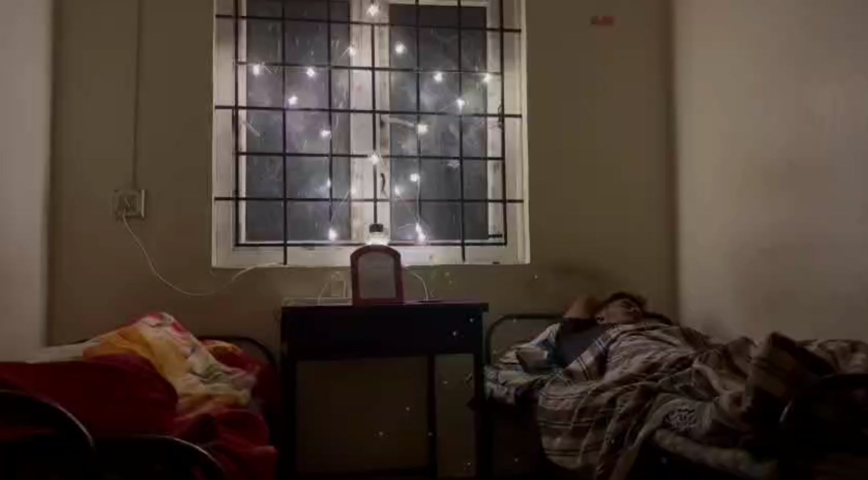
Fig. 3.1: Bedroom set before lighting setup
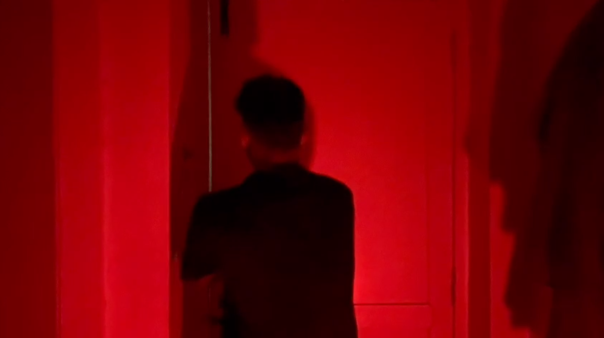
Fig. 3.2: Red light source and gel setup
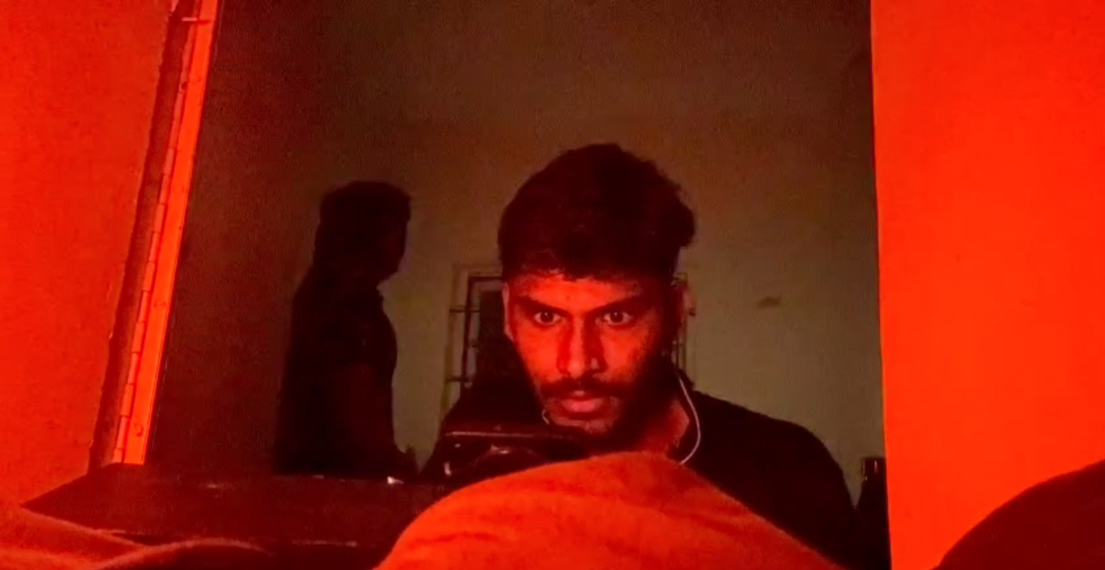
Fig. 3.3: Screenshot – Scene 3: The Red Light
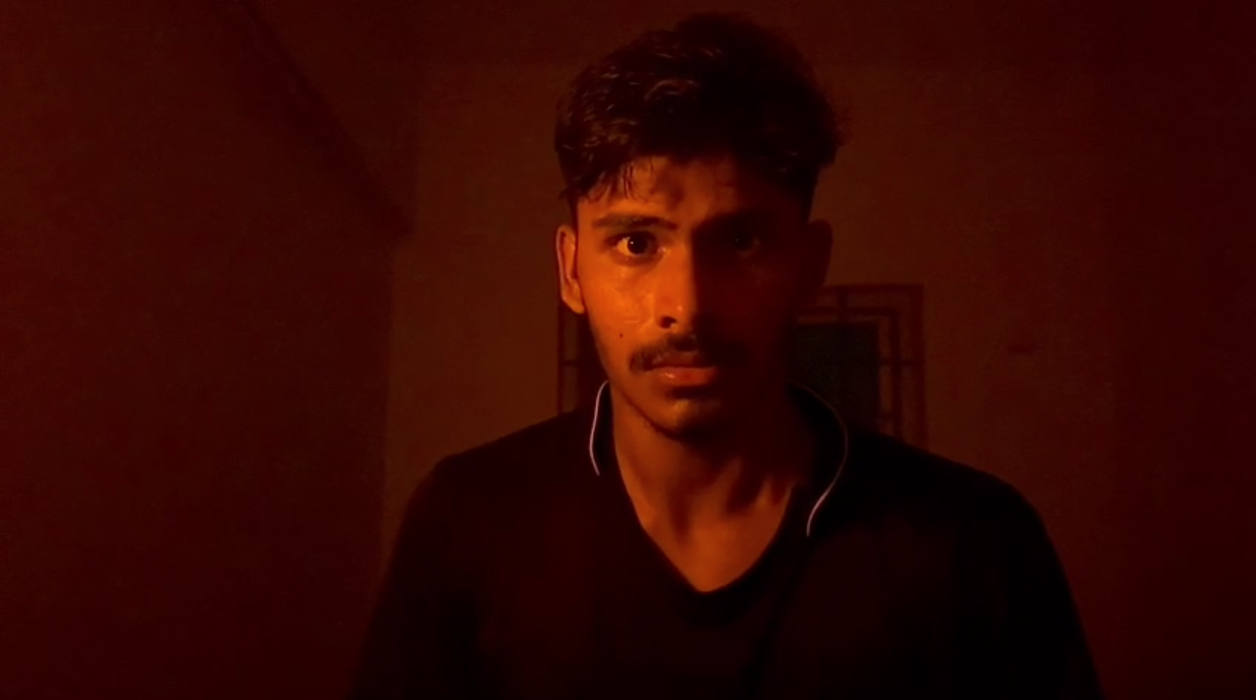
Fig. 3.4: Screenshot – Scene 4: Close-up, Fear
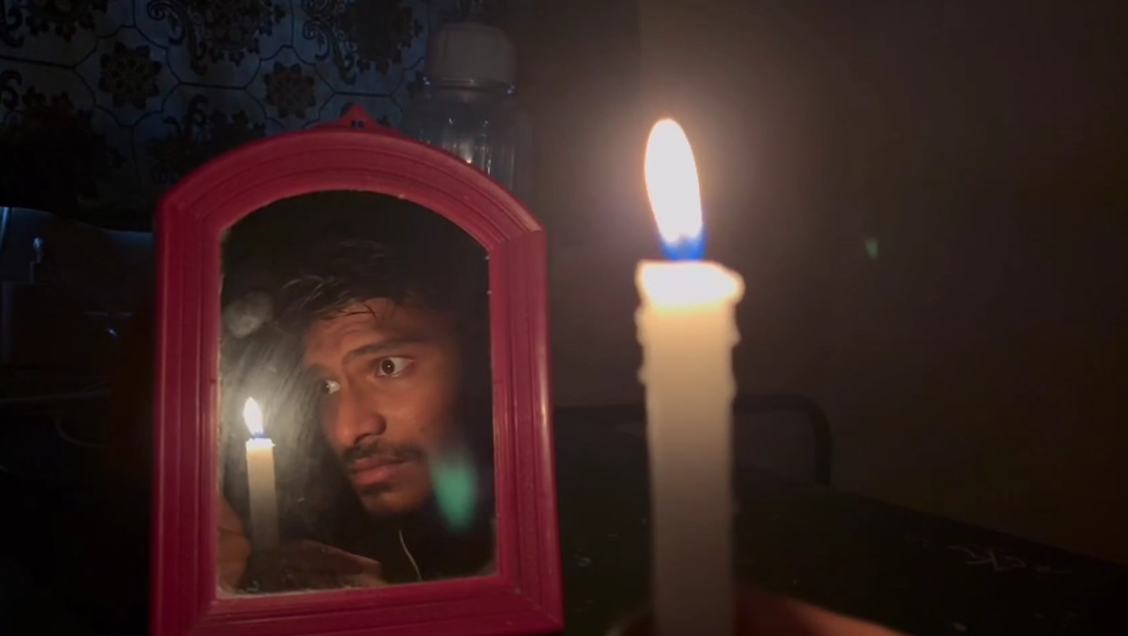
Fig. 3.5: Screenshot – Scene 11/12: The Mirror and Candle

3.4 Direction of Performance
The lead performer, Dhirtha, was directed through rehearsed blocking and repeated takes, with a tripod-mounted monitor used, where possible, to check framing before each take. Performance beats were kept minimal and physical – posture, breathing, and eye-line – favouring restraint over exaggerated reactions to suit the film's understated tone.

3.5 On-Set Screenshots and Title Card
The title card for the film is presented below. The film's title is overlaid in a plain serif typeface on a dim, static shot of the bedroom set, keeping the very first frame consistent with the restrained, atmosphere-led visual style used throughout the film.
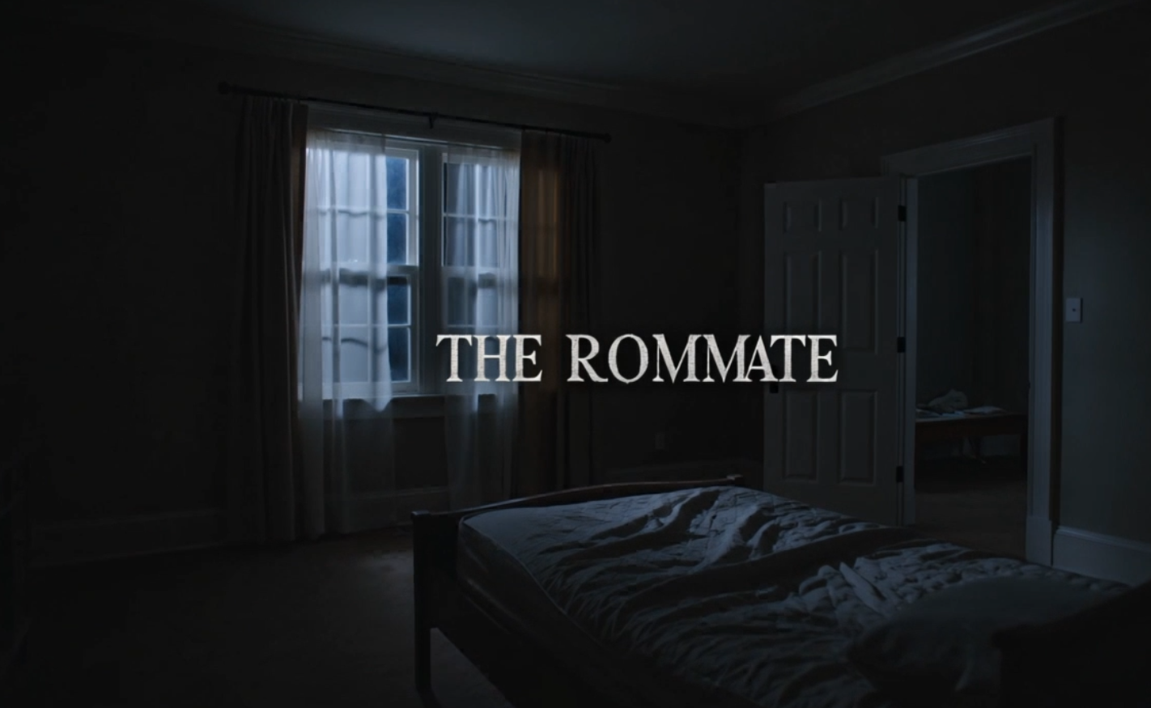
Fig. 3.6: Title Card – “THE ROOMMATE”
CHAPTER 4

POST-PRODUCTION

4.1 Editing Workflow
Footage was imported and organised by scene number matching the script structure (Scenes 1–12), then assembled into a rough cut following the scripted order. Pacing was tightened in the edit, particularly in Scenes 2, 5 and 8, where handheld search footage was trimmed to keep momentum without losing the sense of the character searching the room.
Cross-cutting between the candle flame, the performer's face, and the mirror reflection in Scene 12 was assembled as a three-shot alternating pattern as specified in the script, gradually shortening the duration of each cut to build tension toward the final fade to black.

4.2 Colour Grading
Basic colour correction was applied to balance skin tones under the red practical light without fully neutralising the red cast, since the colour itself is central to the scene's tension. The candlelit mirror sequence was graded slightly warmer and darker at the edges (vignette) to isolate the reflection as the visual focus of the final scene.

4.3 Sound Design and Audio Mixing
Ambient room tone was retained under each scene to preserve spatial continuity. The phone call audio in Scene 6 was kept as original on-set audio, in line with the script's direction that the exact dialogue was not intended to be clearly identifiable, and was left in its raw, slightly muffled form to add to the disorientation. Subtle low-frequency drone elements were layered beneath the red-light scenes to reinforce unease without resorting to jump-scare stingers.

4.4 Title Card and Credits
The opening title card was designed as a simple serif overlay on a static bedroom shot, keeping the very first frame in the same restrained visual language as the rest of the film. The closing credits use a minimalist white-on-black card naming the cast and crew, set against a subtle starfield background.
Fig. 4.1: Title Card of “The Roommate”
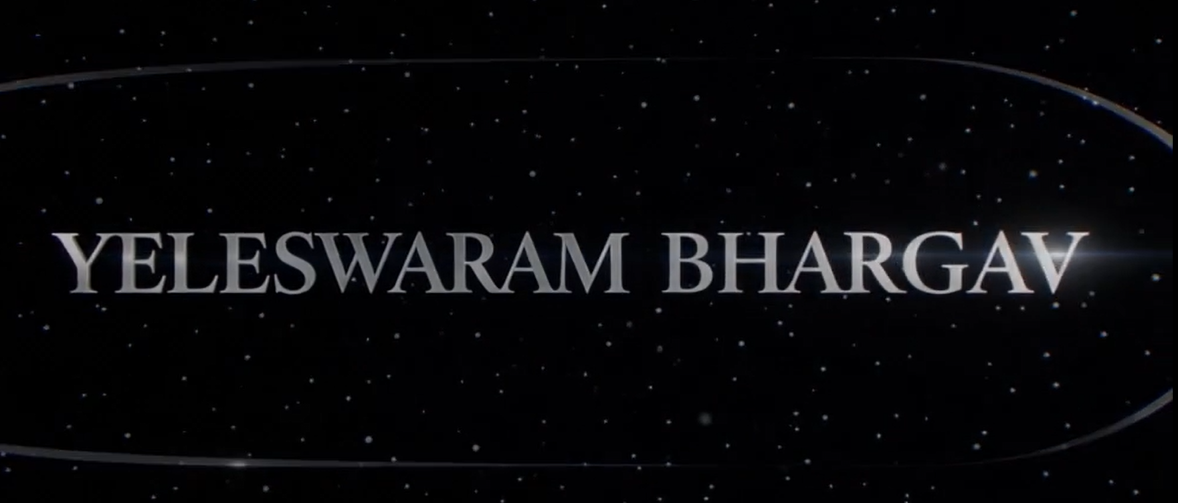
Fig. 4.2: End Credits Frame
CHAPTER 5

EQUIPMENT AND TECHNICAL SPECIFICATIONS
The following equipment and software were used across the production.
Category | Details
Camera | Smartphone camera (primary capture device)
Support | Tripod for static/slow-push shots
Lighting – Key (red) | LED bulb / work light with red gel or colour filter
Lighting – Key (final scene) | Single lit candle
Practical light source (Scene 6) | Smartphone screen (used as an in-scene light source)
Editing Software | Video editing software used for assembly, trimming and cross-cutting
Colour Grading | Built-in colour correction tools of the editing software
Audio Tools | On-device audio recording; basic level and noise adjustment in post

5.1 Technical Specifications
- Resolution: Full HD (1920 × 1080), 30fps / 24fps as per scene requirement
- Aspect Ratio: 16:9
- Runtime: Approximately 3 minutes 42 seconds
- Audio: On-camera/on-device microphone with ambient room tone retained
CHAPTER 6

CHALLENGES FACED AND LEARNING OUTCOMES

6.1 Challenges Faced
- Directing a lead performer while single-handedly operating the camera and lighting meant constant coordination between takes, which required extensive rehearsal to keep blocking and performance consistent.
- Achieving a convincing red-light effect without overexposing the frame or losing facial detail required multiple lighting distance and intensity tests before the final setup.
- Maintaining consistent shadow direction and size across cuts (Scenes 3, 4, 9 and 10) was difficult when the light source had to be repositioned between setups.
- Capturing clean audio for the phone-call sequence (Scene 6) while keeping the dialogue intentionally indistinct, without it sounding like a technical error, required careful mic placement.
- Balancing the candlelight in the final mirror scene (Scenes 11–12) against the surrounding darkness, since a single candle provides very low and uneven light levels for handheld camera equipment.

6.2 Learning Outcomes
- Gained practical understanding of how colour temperature and practical light sources (red gel, candle, phone screen) can drive mood and narrative meaning without dialogue.
- Developed skills in lean production management – planning a shoot that can realistically be executed by a one-person crew across camera, lighting and sound, while directing a single lead performer.
- Learned to plan shot coverage around lighting continuity rather than purely narrative order, grouping scenes by lighting state to minimise setup changes.
- Improved proficiency in post-production editing, particularly rhythm-building through cross-cutting, as used in the final mirror sequence.
- Understood the importance of pre-production documentation (scene breakdown, shot list, schedule) in keeping a low-resource solo shoot on track.
CHAPTER 7

CONCLUSION AND FUTURE SCOPE
“The Roommate” was completed as a single-location, solo-produced psychological horror short film that met its core objective: demonstrating that atmosphere and tension can be built primarily through lighting design, shadow, and pacing rather than dialogue, visual effects, or a large cast and crew. The project provided complete, hands-on exposure to every stage of the filmmaking pipeline – from concept and script through production and post-production – within the scope of the CD23731 Film Making and Radio Podcasting course.
As future scope, the project could be extended by re-shooting select sequences with dedicated lighting equipment (LED panels with adjustable colour temperature) instead of practical bulbs, adding a subtle original score to replace or supplement the ambient drone layer, and expanding the narrative into a longer companion piece that reveals more context around the disturbance hinted at in the phone call. A second pass with a small crew would also allow multi-camera coverage of the mirror sequence for tighter cross-cutting.
REFERENCES

- Original visual script, “THE ROOMMATE” – Exact Visual Script, Horror / Psychological Thriller, Duration – 3 minutes 42 seconds (project script, self-authored).
- Course materials and lecture notes, CD23731 – Film Making and Radio Podcasting, Department of Computer Science and Design, Rajalakshmi Engineering College.
- Bordwell, D., and Thompson, K., Film Art: An Introduction, McGraw-Hill Education, latest edition.
- Brown, B., Cinematography: Theory and Practice – Image Making for Cinematographers and Directors, Routledge/Focal Press, latest edition.
- Rabiger, M., and Hurbis-Cherrier, M., Directing: Film Techniques and Aesthetics, Routledge/Focal Press, latest edition.
ANNEXURE A – FULL VISUAL SCRIPT

Title: THE ROOMMATE | Genre: Horror / Psychological Thriller | Duration: Approximately 3 minutes 42 seconds

SCENE 1 – THE SLEEPING ROOM (INT. BEDROOM – NIGHT)
A bedroom. A young man lies asleep on the bed, covered with a blanket. The room is quiet.
The camera slowly establishes the space around him. The lights begin to dim. The room gradually falls into darkness.

SCENE 2 – SOMETHING WAKES HIM
The young man suddenly wakes up. He sits upright on the bed. He looks around the room. Something feels wrong.
He looks toward different parts of the room, trying to understand what disturbed him. His expression becomes uneasy. The room is now much darker. He remains alert.

SCENE 3 – THE RED LIGHT
A strong RED LIGHT suddenly fills the room. The young man looks toward the source. A hand reaches toward a wall switch or light control. The red light continues to dominate the room.
The atmosphere changes completely. The young man stands in front of the red-lit background. His shadow appears prominently on the wall. He slowly moves. His silhouette and shadow create an unnatural and disturbing image.

SCENE 4 – FEAR (CLOSE-UP)
The young man's face. He is visibly frightened. He touches his face and looks around. Behind him, the room remains covered in red light.
He turns repeatedly, checking his surroundings. The shadows on the wall continue to follow his movements. He becomes increasingly anxious.

SCENE 5 – SEARCHING FOR ANSWERS
The young man looks toward the bed and nearby objects. He reaches forward. He searches around him. His hands move across the bed and surrounding area. He appears to be looking for his phone. He finally picks it up.

SCENE 6 – THE PHONE
The young man holds his phone. The screen illuminates his face. The red light still surrounds him. He looks at the screen. His expression changes. He appears disturbed by what he sees or hears. He brings the phone closer. He then places it against his ear.
PHONE CALL / SOUND: The exact words are not visually identifiable from the footage, so this section contains the original audio from the film rather than newly invented dialogue.
The young man listens. He becomes more concerned. He looks around while still holding the phone.

SCENE 7 – BACK TO THE ROOM
A sudden transition. The room appears brighter and more normal. The bed is shown. The young man looks around cautiously. The lighting begins to shift again. He moves toward the area near the door and mirror. He holds the phone/light source. He scans the room.

SCENE 8 – SOMETHING IS IN THE ROOM
The young man reaches toward the bed. He looks around. His hand moves slowly, as though he is checking whether someone or something is there. The camera focuses on his movements and his reaction. He suddenly looks to one side. The tension increases. He turns his head. Something has caught his attention.

SCENE 9 – THE LIGHT
The young man sits and looks upward. He appears to notice something above or around him. A close shot shows his hand near an electrical connection or switch. He interacts with it. The lighting changes again. He moves away.

SCENE 10 – THE SHADOW
The young man walks through the room. His silhouette is visible against the wall. A large shadow appears beside him. He stops. He turns. The room remains dimly illuminated. He looks down and then around, trying to remain calm. The shadow effect becomes an important part of the scene.

SCENE 11 – THE MIRROR
The young man approaches the mirror. A candle is placed in front of it. The candle is lit. The flame becomes the main source of light. He slowly sits or leans toward the mirror. The candlelight illuminates his face. The rest of the room remains dark.

SCENE 12 – THE REFLECTION (CLOSE-UP – MIRROR)
The young man's face appears in the mirror. The candle burns in front of him. He stares directly at his reflection. The camera alternates between the candle flame, his face, and his reflection in the mirror. The atmosphere becomes increasingly unsettling. He continues staring. The candle flame flickers.

FINAL SCENE
The camera remains focused on the mirror and candle. The young man's reflection is still visible. The room gradually becomes darker. The candle remains burning. CUT TO BLACK.

